Questions to explore, analyze and visualize:
- Analyze Salary spread across country/departments /gender etc
- Relationship between Salary and Employee Rating – e.g., are good paid more?
--- cannot do a straight correlation between salary and employee rating as rating is words. Could change to a scale system and see if there is a relationship that way. E.g., Excellent = 5, Good = 4, Average = 3, Poor = 2, Very Poor = 1
- Growth over time, increase in employees, how long, over time. Was there a spike is it growing or decreasing
- Regional Scorecard: India vs New Zealand – compare bits out of each

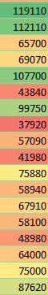
Options to check salary spread:
View at a glance:
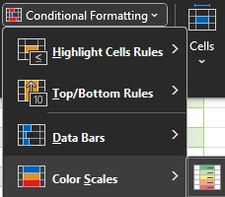
This puts all salaries into a colour band. Green being highest and reducing to the lower band at red. Will enable us to see where people are low but doesn’t really give much more detail
------ :E.g.

Not optimal. If very large data, it completely weird. Additional info can be obtained by going:

Basic analysis to see spread of data – histogram:
Start the bucket at 40k and goes up by 10k for each slot in the histogram
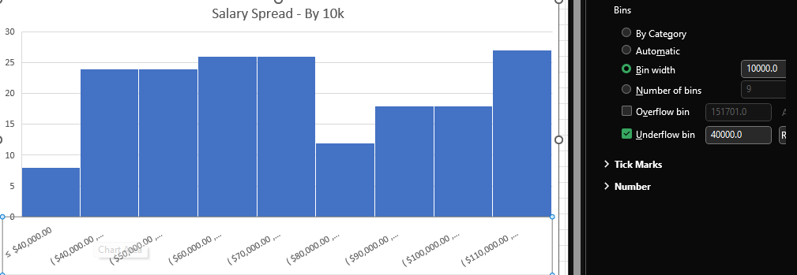
Can see that few are under 40k (7) and the rest are above and it’s fairly evenly spread to begin then skews at the end

Box and Whisker: X is the average, line is median. Box at top is 75th percentile, bottom is 25th percentile.
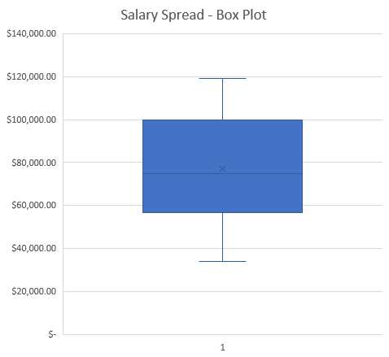
So on this, we can see the mid 50% (25th to 75th percentile) cover a bit under 60k to roughly 100k.

This will let us see any outliers e.g., insanely over or under salaried. But our data has none and the extreme ends are simply the 0th and 100th percentiles

Relationship between Salary and Employee Rating – e.g., are good employes paid more?
Option 1 - Pivot table:
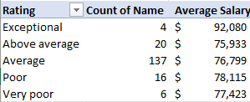
Lets us see how many people fall into each category and how much the average salary for those in each category differs depending on their rating
Note: had to manually change the order of things so you can read from best to worse and understand a tad easier.
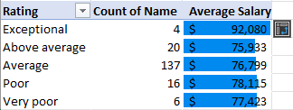
Conditional formatting data bars added to entire pivot table. Showing that the average is higher in poor/very poor than it is in above average. --- not overly fond of this one it doesn’t look ideal. Rating vs salary isn’t telling us a lot in this case. Also average is a significant chunk so harder to tell about the others.
Curious whether there was a relationship so wanted to do a c orrelation. Have to change from letters to numbers so:
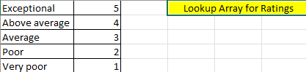
Xlookup vs IFS
Scatterplot demonstrating the relationship between salary and rating. With a majority of the ratings being average, it’s hard to draw any meaningful conclusions about the relationship. Especially as the other ratings have been few and are unlikely to be reliable information going forward.

*** Growth over time, increase in employees, how long, over time. Was there a spike is it growing or decreasing
Can plot head count/employee’s vs their join date. Maybe section by month/year to see increase.
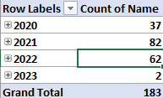
This lets us see how many individuals joined in each year by counting individual names. However, it could be confusing to someone looking at a glance as it’s hard to figure if that’s total overall or just that year so a cumulative count could be handy.

Line graph below shows us the hires and peaks and troughs in hiring but doesn’t show us where the company is at, how many people in total etc. The growth of the company just shows we hired some here, some not here.

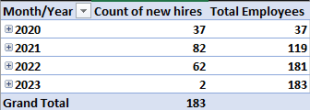

I would rather this to show how many you end up in total as year goes on but the count is important as it goes a big spike then less so suggesting lower amounts of peeps (unsure on where in 2023 the data is at so hard to say if 2 is panic no expansion or simply in January)
Can also do this which will give the cumulative frequency in a different column and changes the graph drastically (see below)
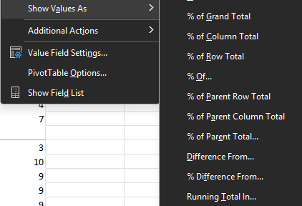

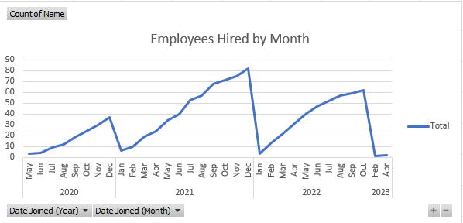
Because we’re doing it by month/year it looks like it resets to 0 employees each year and then builds back up

Going to make a cumulative employee count column, powerpivot could be done in the future. For now we’re going to do several forumals
This will write out the sequence of 1-36 (3 years total for later working)
- why does this start in may? Is it because we did 4+1? Weird function.
So Date to start from 01.05.2020 (is the weird way excel has it), then we want to use our sequence (so it goes from 1 in our SEQUENCE (at Q3) and then has means it goes through the entire list) +0 he added cos it didn’t work without? Idk about thatone.

=COUNTIFS(staff[Date Joined],">="&R3)
---------- COUNTING staff joings IF, they joined on the date or greater than the date in R3. Because R3 has used a formula already, you have to add & else it will hate it and not work. However, we need to add extra to ensure it runs the total

Full explanation:
Counting how many staff joined on related dates.
Criteria, initially has to be equal to or greater than the date in the list we created but we also need to an endpoint so it has to be less than or equal to the end of the month on the date we created (works as we’re doing months only). Both required & due to formula in the list created. R3 is same in both as that is the moth we’re working on, in EOMONTH, you choose the date and 0 means just that date nothing else.
We then do a running total on our lists:
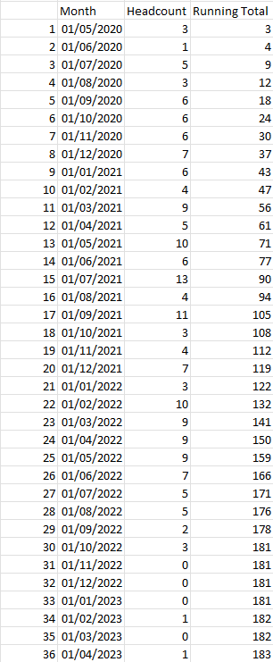
So we can see the created 36 months using =SEQUENCE(36), months created with EDATE, headcount for each of the months and then the sum of the first row to the first row. It’s absolute reference so next line will be the sum of the first row and the second row. Next is sum of first row and second and 3rd. Etc etc

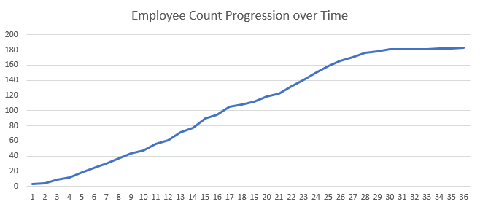
Following that we chart the growth:

Last: Report card of India vs New Zealand
Looking at headcount:
% staff female:
C3/K3 being the position of each count respectively.
AVG Salary:

Pivot table creation to analyse employees by department for india and new zealand
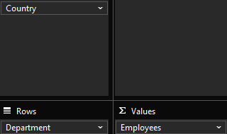
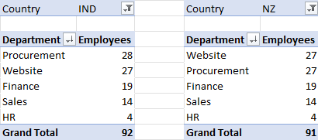
Results in bar charts (nz)
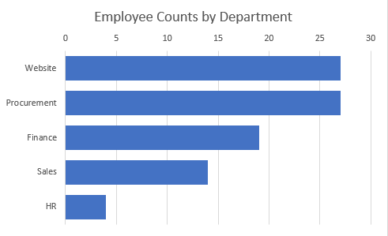
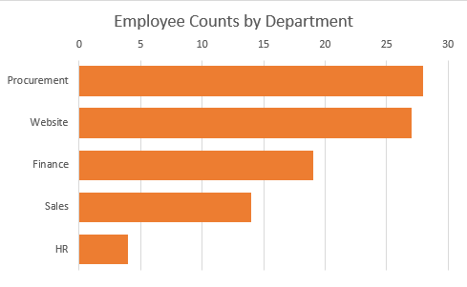
India bar chart.

Final Scorecard comparing 2 sets of employees
